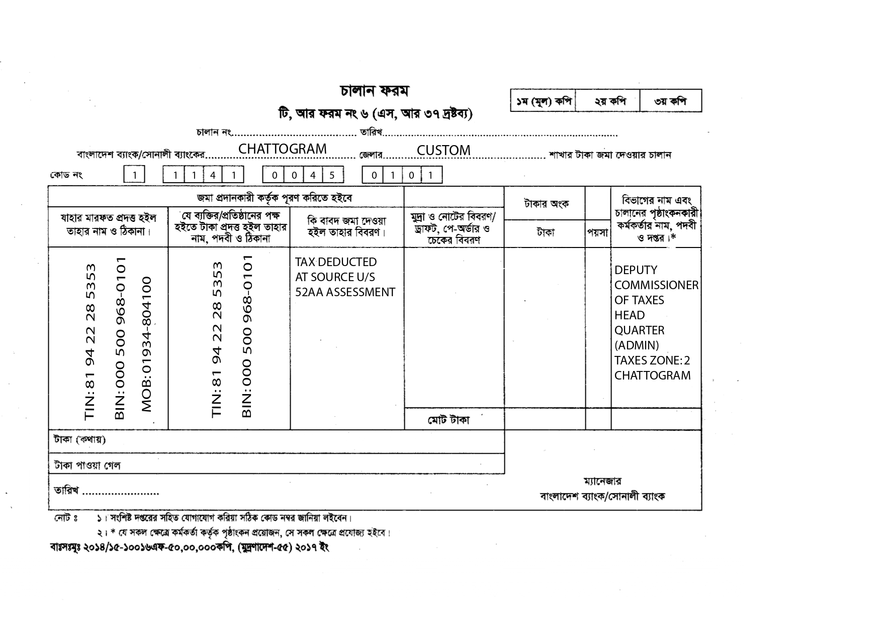

${day}/${month}/${year}

YEAR: ${year}-${yearnxt}  
 MV. ${vessel}  
 NRT: ${vsl_nrt} X 10/-   
 TK: ${amount}/-  
 10% AIT ON   
 LIGHT DUES  
 TK: ${vat10}/- ${vat10}/-   
 ${amountinword}

COMMENTS: 10% AIT ON LIGHT DUES OF MV. ${vessel}